|  |  |  |  |  |  |
| --- | --- | --- | --- | --- | --- |
| |  |  |  | | --- | --- | --- | |  | **Sudan University of Science and Technology**  **College of Engineering**  **School of Electronics Engineering**  **Design of Internet of Things Based Smart Farming System**  A Research Submitted in Partial Fulfillment for the Requirement Degree of the B.Sc. (Honors) in Electronic Engineering |  | |  |  |

**Prepared By:**

1. Babiker Bushra Mostafa Ahmed.
2. Mohammed Ismail Mohammed Warith Aldeen.
3. Mohammed Salah Hessain Dafa Allah.
4. Yassir Abdelkarim Ahmed Osman.

**Supervisor:**

**Dr. Hisham Ahmed Ali.**

November 2021

**بسم الله الرحمن الرحيم**

# استهلال

**قال تعالى:**

(**ولقد كرمنا بني أدم وحملناهم في البر والبحر ورزقناهم من الطيبات وفضلناهم على كثير ممن خلقنا تفضيلا**)

**صدق الله العظيم**

**سورة الإسراء**

**الأيه (70)**

# Dedication

# 

# Acknowledgment

# 

# Abstract

# المستخلص

# TABLE OF CONTENT

استهلال II

Dedication III

Acknowledgment IV

Abstract V

المستخلص VI

TABLE OF CONTENT VII

List of Figures X

Abbreviations XII

CHAPTER ONE 1

Introduction 1

1.1 Introduction 2

1.2 Problem Statement 3

1.3 Proposed solution 4

1.4 Research Objectives 4

1.5 Methodology 5

1.6 Thesis Structure 6

CHAPTER TWO 8

LITERATURE REVIEW 8

2.1 Background 9

2.1.1 Arduino Mega 2560 9

2.1.2 DOIT ESP32 DEVKIT V1 10

2.1.3 Breadboard 12

2.1.4 Temperature sensor (DTH11) 13

2.1.5 Soil moisture sensor 14

2.1.6 Water sensor 15

2.1.7 Photo resistor LDR 16

2.1.8 3-wire fan 16

2.1.9 Water Pump (Roinco R365 DC water Pump 12 V) 17

2.1.10 Jumper Wire/ Hooked wire 18

2.1.11 The Server(ThingsBoard) 20

2.1.11.1 IoT Rule Engine 21

2.1.11.2 RPC Server 21

2.1.12 IoT protocols 22

2.1.12.1 MQTT 22

2.1.12.1.1 Why MQTT? 23

2.1.12.1.2 MQTT Publish / Subscribe Architecture 24

2.1.12.2 CoAP 25

2.1.13 Flutter 25

2.2 Literature Review 26

CHAPTER THREE 28

SYSTEM DESIGN AND IMPLEMENTATION 28

3.1 Overview of the smart farming system 29

3.2 Methodology 29

3.3 Software Requirements 32

3.4 System Architecture 33

3.5 Hardware implementation 34

References: 39

# List of Figures

# Abbreviations

# CHAPTER ONE

# Introduction

## Introduction

Internet of Things was introduced in 2009 and it aims in incorporating all gadgets and devices to the web. “The Internet of Thing” is changing every second. IoT enhances our lives in terms of business; medical-health and society by modifying products which are IoT based making our life easier.

Internet of thing is an emerging topic of technical, social and economical development. Products like consumer items, big machineries, vehicles, mechanical and utility segment, sensors and others are connected to internet availability giving necessary information that guarantee to change the manner in which we work making our life simpler.

The advancement in the modern technology like IoT, AI & cloud computing led us to think about using it to improve our live. The Internet of Things (IoT) has proven to be revolutionary in its expansion. IoT technology has entered homes and businesses with applications of IoT ranging from home automation, logistics and automotive to health and fitness industry. It has also touched the Agriculture industry and has a lot of benefits of IoT in agriculture by introducing connected devices.

Tools used in IoT technologies:

1- Hardware and Software system.

2- Sensing Technologies.

3- Software Application.

4- Communication System.

The above cited depicts that through smart farming concept, we can enhances the software application, communication system, uses hardware and software systems like agricultural stick, sensors like temperature and soil moisture sensor. Software application used is Arduino IDE which takes data and display in Arduino board. This also builds up communication system between the sensors and the user in a form of notification.

## Problem Statement

The purpose of this proposal is to increase the crop production, and manage the resources effectively, so the system controls the irrigation and fertilization per the requirements of the cultivated crops, and creates the appropriate conditions, such as nutrients, humidity, soil moisture and temperature, for the better growth of the crops. The system provides precise monitoring and controlling, and this results in enhancing production and saving resources like: water and electricity and fertilizer, also this system solves the problem of monitoring which it is critical and important production factor.

## Proposed solution

The proposed solution is to provide adaptive and remote control and monitoring system for greenhouse. The system uses Arduino mega with Wi-Fi module(ESP32) to communicate with Server and mobile app, The Arduino connected to the greenhouse devices to perform control and monitor functions.

## Research Objectives

The aim of this project is to develop a prototype for a greenhouse that will enable farmer to control and monitor the(greenhouse condition) status of the greenhouse.

Objectives:

* full adaptive system:

system automatically configure and adjust the greenhouse environment(temperature, irrigation, light) for the planted crop.

* remote control of the system :

by using the mobile app farmer can remotely enable/disable:

-irrigation system.

-cooling system.

-light system.

* Full monitoring of the greenhouse through the mobile app

## Methodology

The system uses IoT and cloud technology and set of sensors including humidity sensor, moisture sensor, light sensor, and temperature sensor and water level sensor. And all this sensors will be installed throughout the fields, it continuously collect data, and send them to the server to be processed and then the server deicide to take action or sent notifications containing information about the farmland to an android app.

There will be a database containing information about the crops (required nutrients, temperature, irrigation schedule and humidity), and threshold values for the crops, so the sensors collect the data from the fields and send it to an Arduino and then forwarded to the server by NODEMCU(ESP32), and the server compares this data with the threshold values that stored on the database and according to the result it will send a command to the system to do the required operation, also the server will send a live data about the greenhouse environment to the android app.

## Thesis Structure

The thesis contains five chapters and it is structured as follows:

Chapter onedescribe a theoretical background in a field of Smart farming. Chapter two describe hardware components and shows related works in a field of smart farming .Chapter three describes system development and all steps of simulation and implementation and software design and implementation for the project. Chapter four discusses the results of simulation and implementation for the project. Chapter five explain the conclusion and the future ideas that can be performed.

# CHAPTER TWO

# LITERATURE REVIEW

## Background

Smart farming technology is the use of IoT which connects devices such as arduino with the sensor and performing task such as getting reading from the arduino software and making decision according to it .it helps in the temperature, humidity, ph scale management. The development of Internet of Things Smart Farming based devices is day by day turning the face of agriculture production by not only enhancing it but also making it cost-effective and reducing wastage. Today countless farms around the world are beginning to implement IoT-enabled technologies and seeing the benefits. More applications are set to emerge taking the IoT in agriculture to new levels.

## Arduino Mega 2560

The **Arduino Mega 2560** is a microcontroller board based on the [ATmega2560](http://ww1.microchip.com/downloads/en/DeviceDoc/Atmel-2549-8-bit-AVR-Microcontroller-ATmega640-1280-1281-2560-2561_datasheet.pdf). It has 54 digital input/output pins (of which 15 can be used as PWM outputs), 16 analog inputs, 4 UARTs (hardware serial ports), a 16 MHz crystal oscillator, a USB connection, a power jack, an ICSP header, and a reset button. It contains everything needed to support the microcontroller; simply connect it to a computer with a USB cable or power it with an AC-to-DC adapter or battery to get started. The Mega 2560 board is compatible with most shields designed for the Uno and the former boards Duemilanove or Diecimila.

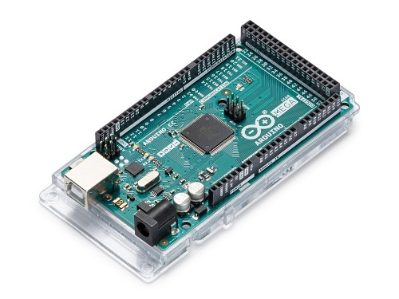

Figure 2-1: Arduino mega 2560

## 

## DOIT ESP32 DEVKIT V1

ESP32 is the name of the chip that was developed by Espressif Systems. This provides Wi-Fi (and in some models) dual-mode Bluetooth connectivity to embedded devices. While ESP32 is technically just the chip, modules and development boards that contain this chip are often also referred to as “ESP32” by the manufacturer.

When it comes to iot, the ESP32 is a chip that packs a powerful punch. The ESP32 is a follow-up to the ESP8266. This low-cost, low-power system on a chip (SoC) series was created by Espressif Systems. Based on its value for money, small size and relatively low power consumption, it is well suited to a number of different IoT applications.

Models are available with combined Wi-Fi and Bluetooth connectivity, or just Wi-Fi connectivity.

ESP32 has many applications when it comes to the Internet of Things (IoT). Here are just some of the IoT functions the chip is used for:

**Networking**: The module’s Wi-Fi Antenna and dual-core enables embedded devices to connect to routers and transmit data.

**Data Processing:** Includes processing basic inputs from analog and digital sensors to far more complex calculations with and RTOS or Non-OS SDK.

**P2P Connectivity:** Creates direct communication between different ESPs and other devices using IoT P2P connectivity.

**Web Server:** Access pages written in HTML or development languages.

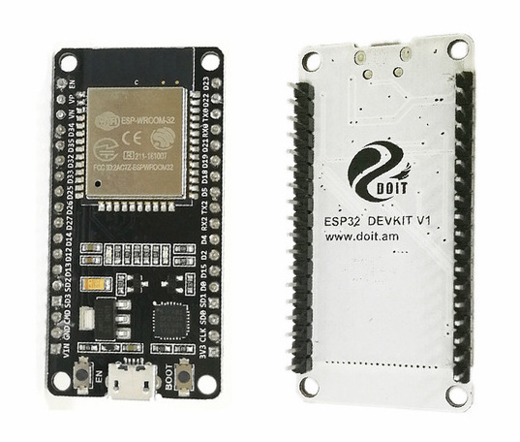Figure 2-2: DOIT Esp32 DevKit v1

## Breadboard

A breadboard is a construction base for prototyping of electronics. Originally it was literally a bread board, a polished piece of wood used for slicing bread. In the 1970s the solder less breadboard became available and now a days the term "breadboard" is commonly used to refer to these. Because the solder less breadboard does not require soldering, it is reusable. This makes it easy to use for creating temporary prototypes and experimenting with circuit design. For this reason, solder less breadboards are also extremely popular with students and in technological education. Now days breadboard are being used for small projects and all kinds of prototype electronic devices.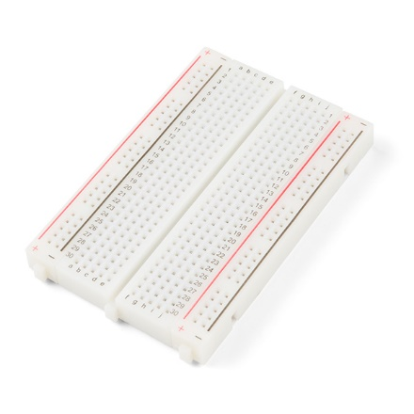

Figure 2-3: Breadboard

## Temperature sensor (DTH11)

The DHT11 is a basic, ultra low-cost digital temperature and humidity sensor. It uses a capacitive humidity sensor and a thermistor to measure the surrounding air, and spits out a digital signal on the data pin (no analog input pins needed). Its fairly simple to use, but requires careful timing to grab data. The only real downside of this sensor is you can only get new data from it once every 2 seconds, so when using our library, sensor readings can be up to 2 seconds old.

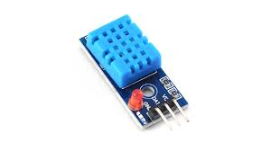

Figure 2-4: DHT11

## Soil moisture sensor

The Soil Moisture Sensor is a simple breakout for measuring the moisture in soil and similar materials. The soil moisture sensor is pretty straightforward to use. The two large, exposed pads function as probes for the sensor, together acting as a variable resistor. The more water that is in the soil means the better the conductivity between the pads will be, resulting in a lower resistance and a higher SIG out. This version of the Soil Moisture Sensor includes a 3-pin screw pin terminal pre-soldered to the board for easy wiring and setup.

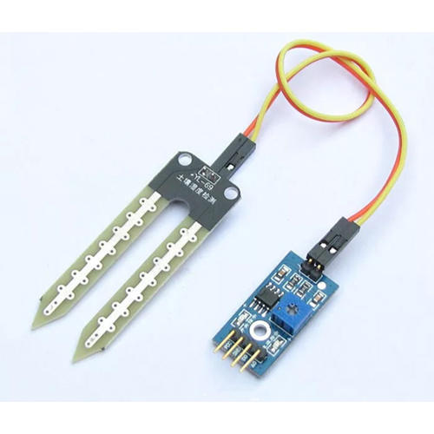

Figure 2-5: Soil Moisture

## Water sensor

Water sensor brick is designed for water detection, which can be widely used in sensing rainfall, water level, and even liquid leakage.

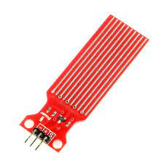

Figure 2-6: Water sensor

## Photo resistor LDR

Photo resistors, also known as light dependent resistors (LDR), Light Sensors are photoelectric devices that convert light energy (photons) whether visible or infra-red light into an electrical (electrons) signal. The light sensor is a passive devices that convert this “light energy” whether visible or in the infra-red parts of the spectrum into an electrical signal output. Light sensors are more commonly known as “Photoelectric Devices” or “Photo Sensors” because the convert light energy (photons) into electricity (electrons).

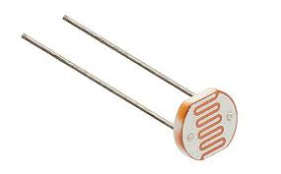

Figure 2-7: Photo resistor LDR

## 3-wire fan

A 3-wire fan has power, ground, and a tachometric (“tach”) output, which provides a signal with frequency proportional to speed. ... A 3-wire fan can be controlled using the same kind of drive as for 2-wire fans—variable dc or low-frequency PWM.

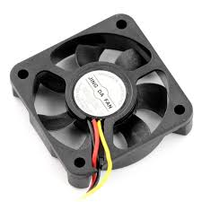

Figure 2-8: 3-wire fan

## 

## Water Pump (Roinco R365 DC water Pump 12 V)

The Roinco R365 DC water Pump 12 Vis the perfect choice for any project that requires water to be moved from one place to another.

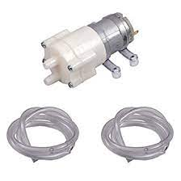

Figure 3-10: Roinco R365 DC water Pump

### 

## 

## Jumper Wire/ Hooked wire

Jumper wire and hooked wire is an electrical cable used in an Iot application for interconnecting arduino with different sensors with the bread board..It is normally used for making connection between components like Arduino (pin) with the Temperature sensor. It helps in completing the circuit giving the readings.

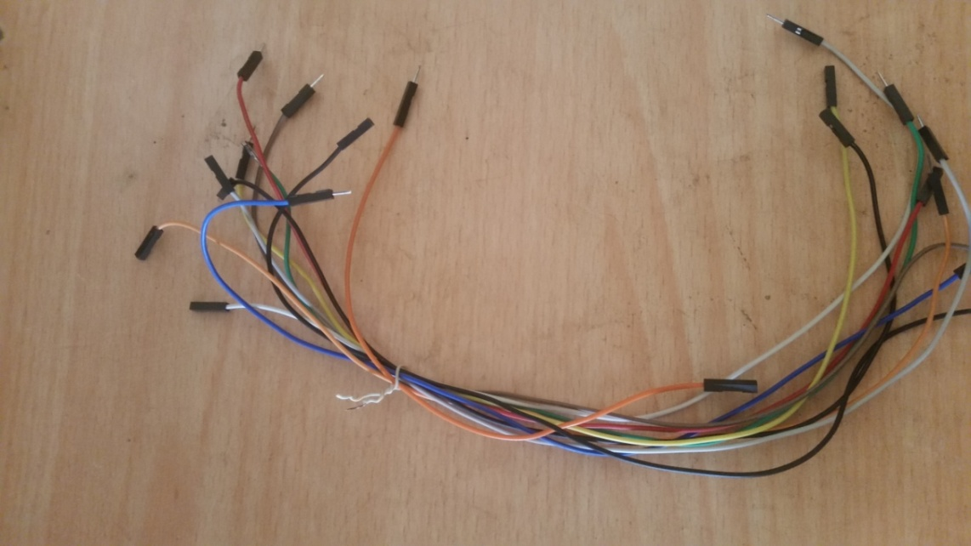

Figure 3-11: jumper wire

#### In Jumper wire, we have three category and we used all

##### Male to male

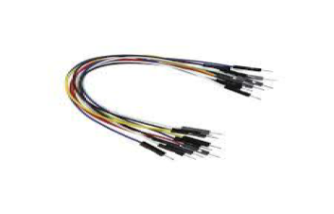

Figure 3-12: jumper wire(m to m)

##### Male to female

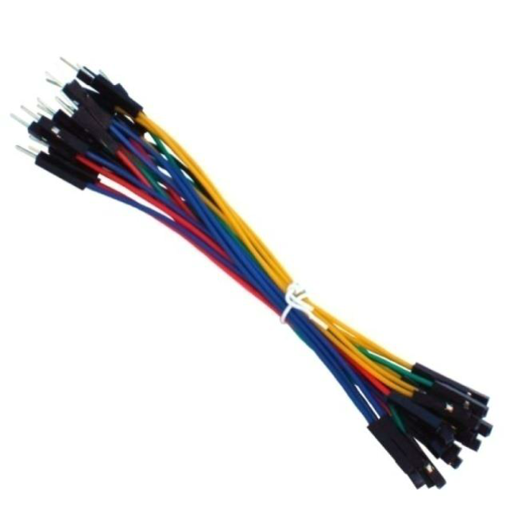

Figure 1-13: jumper wire(m to f)

##### Female to female

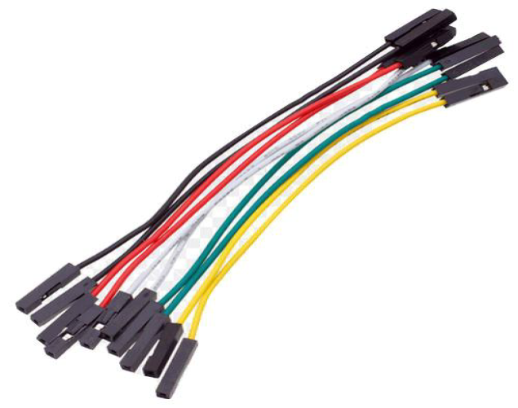

Figure 1-14: jumper wire(f to f)

## 

## The Server (ThingsBoard)

ThingsBoard is an open-source IoT platform for data collection,processing, visualization, and device managementIt enables device connectivity via industry standard IoT protocols - MQTT, CoAP and HTTP and supports both cloud and on-premises deployments. ThingsBoard combines scalability, fault-tolerance and performance so you will never lose your data. ThingsBoard provides the user interface and REST APIs to provision and manage multiple entity types and their relations in your IoT application. [7]

## 

### IoT Rule Engine

It process incoming device data with flexible rule chains based on entity attributes or message content. Forward data to external systems or trigger alarms using custom logic. Configure complex notification chains on alarms. Enrich server-side functionality or manipulate your devices with highly customizable rules. Define your application logic with drag-n-drop rule chain designer. [7]

### RPC Server

A remote procedural call (RPC) server is a network communication interface that provides remote connection and communication services to RPC clients. It enables remote users or RPC clients to execute commands and transfer data using RPC calls or over the RPC protocol.

Techopedia Explains Remote Procedural Call Server (RPC Server):

An RPC server works in a type of client/server model where the RPC server provides application/server services and features to remotely connected RPC clients. Typically, an RPC server works when a request is received from an RPC client. This request can be for server access, data or any other server-based request. All communication between the RPC server and RPC client is performed over the RPC server. The RPC server manages all the conversations between the server and client device.[8]

## IoT protocols

The IoT needs standard protocols. Two of the most promising for small devices are MQTT and CoAP. Both MQTT and CoAP Are open standards , better suited to constrained environments than HTTP Provide mechanisms for asynchronous communication, Run on IP, Have a range of implementations.

### MQTT

## 

MQTT is an OASIS standard messaging protocol for the Internet of Things (IoT). It is designed as an extremely lightweight publish/subscribe messaging transport that is ideal for connecting remote devices with a small code footprint and minimal network bandwidth. MQTT today is used in a wide variety of industries, such as automotive, manufacturing, telecommunications, oil and gas, etc

MQTT gives flexibility in communication patterns and acts purely as a pipe for binary data.[9]

### Why MQTT?

-Lightweight and Efficient:

MQTT clients are very small, require minimal resources so can be used on small microcontrollers. MQTT message headers are small to optimize network bandwidth.

- Reliable Message Delivery

Reliability of message delivery is important for many IoT use cases. This is why MQTT has 3 defined quality of service levels: 0 - at most once, 1- at least once, 2 - exactly once

- Bi-directional Communications

MQTT allows for messaging between device to cloud and cloud to device. This makes for easy broadcasting messages to groups of things.

- Support for Unreliable Networks

Many IoT devices connect over unreliable cellular networks. MQTT’s support for persistent sessions reduces the time to reconnect the client with the broker.

- Scale to Millions of Things

MQTT can scale to connect with millions of IoT devices.

-Security Enabled

MQTT makes it easy to encrypt messages using TLS and authenticate clients using modern authentication protocols, such as OAuth.

### MQTT Publish / Subscribe Architecture

## 

Figure 1-15: mqtt publish / subscribe

### CoAP

Constrained Application Protocol (CoAP) is a specialized Internet application protocol for constrained devices, It enables those constrained devices called "nodes" to communicate with the wider Internet using similar protocols. CoAP is designed for use between devices on the same constrained network (e.g., low-power, lossy networks), between devices and general nodes on the Internet, and between devices on different constrained networks both joined by an internet. CoAP is also being used via other mechanisms, such as SMS on mobile communication networks.

CoAP is a service layer protocol that is intended for use in resource-constrained internet devices, such as wireless sensor network nodes. CoAP is designed to easily translate to HTTP for simplified integration with the web, while also meeting specialized requirements such as multicast support, very low overhead, and simplicity. Multicast, low overhead, and simplicity are important for IoT and M2M communication, which tend to be deeply embedded and have much less memory and power supply than traditional internet devices have. Therefore, efficiency is very important. CoAP can run on most devices that support UDP or a UDP analogue.[10]

## Flutter

it is an open-source UI software development kit created by Google. It is used to develop cross platform applications for Android, iOS, Linux, Mac, Windows, Google Fuchsia, and the web from a single codebase. The first version of Flutter was known as codename "Sky" and ran on the Android operating system.[11]

## 2.2 Literature Review

The technological development in Wireless Sensor Networks made it possible to use in monitoring and control of greenhouse parameter in precision agriculture .[1]

After the research in the agricultural field, researchers found that the yield of agriculture is decreasing day by day. However, use of technology in the field of agriculture plays important role in increasing the production as well as in reducing the extra man power efforts. Some of the research attempts are done for betterment of farmers which provides the systems that use technologies helpful for increasing the agricultural yield. A remote sensing and control irrigation system using distributed wireless sensor network aiming for variable rate irrigation, real time in field sensing, controlling of a site specific precision linear move irrigation system to maximize the productivity with minimal use of water was developed by Y. Kim .[2]

The system described details about the design and instrumentation of variable rate irrigation, wireless sensor network and real time in field sensing and control by using appropriate software. The whole system was developed using five in field sensor stations which collects the data and send it to the base station using global positioning system (GPS) where necessary action was taken for controlling irrigation according to the database available with the system. The system provides a promising low cost wireless solution as well as remote controlling for precision irrigation .[3]

And it gives out a method for testing the soil fertility depending on the values collected by the sensors. The soil fertility once determined, is used to suggest the best suitable soil fertilizer for the crop .[4]

Advancements also bring productivity. So, with the help of IoT, farmers will be able to manage Livestock like cow, sheep and other animals as well with their health tracking also possible as discussed by S. Jegadeesan .[5]

In the studies related to wireless sensor network, researchers measured soil related parameters such as temperature and humidity. Sensors were placed below the soil which communicates with relay nodes by the use

of effective communication protocol providing very low duty cycle and hence increasing the life time of soil monitoring system. The system was developed using microcontroller, niversal asynchronous receiver transmitter (UART) interface and sensors while the transmission was done by hourly sampling and buffering the data, transmit it and then checking the status messages. The drawbacks of the system were its cost and deployment of sensor under the soil which causes attenuation of radio frequency (RF) signals .[6]

# CHAPTER THREE

# SYSTEM DESIGN AND IMPLEMENTATION

## Overview of the smart farming system

The system revolves around building smart farming system for green houses, which performs the cultivating processes from irrigation, fertilization and the preparation of the appropriate conditions for the plant (temperature, humidity, …etc.) automatically, and it also provide additional facility of monitoring and controlling the green house remotely using mobile application.

This chapter talks about the simulation of the system and the implementation of the hardware and connecting the hardware with the server and mobile application.

## Methodology

After gathering information about greenhouse and take a deep understanding about how they works, we came up with a design that satisfies all the requirements .

After that and by using Proteus 8 professional software simulation we made a simulation for the system that cover just the hardware parts ( connection the sensor and actuators with the Arduino ). We have connected sensors including humidity sensor, moisture sensor, light sensor, and temperature sensor and water level sensor with Arduino and showed their data on LCD, then used these data to control the actuators automatically by comparing them with threshold values and taking an action such as opening fan or operating the motor or turn on/off the light as presented in this picture:

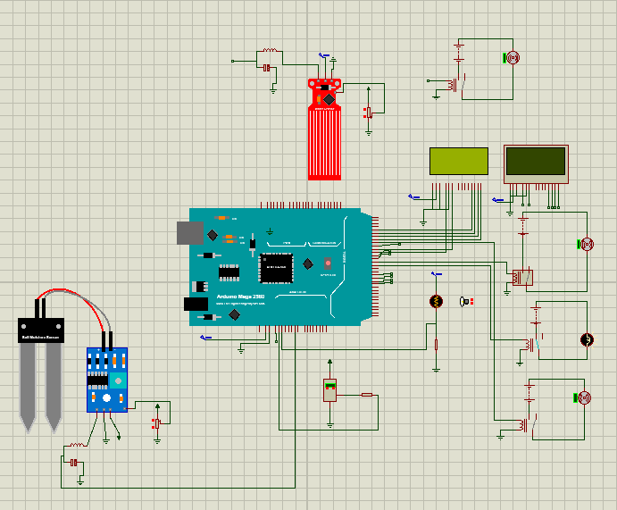

Figure 1-1: Hardware simulation

After that we implemented the hardware by connecting the sensors and the actuators(fan, lamp, motor and water pump) and wi-fi module (ESP32) with the Arduino .

After connecting the hardware we configured the Arduino to read sensors data and passing them to the ESP32. And also we configured the ESP32 to receive data from the Arduino and send them to the server through wi-fi connection. and also we configured the server to store and process the incoming data and send the command back to the ESP. And also we configured the server to send the data to the Android app for monitoring purpose.

### hardware pictures ###################

After that we developed the Android app using flutter framework to receive data from the server to show it in the monitor screen. And also we developed control screen that control buttons that enables the users to control the actuators remotely by opening and closing them. And lastly we developed the profile screen. From which the farmer can select the desired plant profile to configure the environment of the greenhouse.

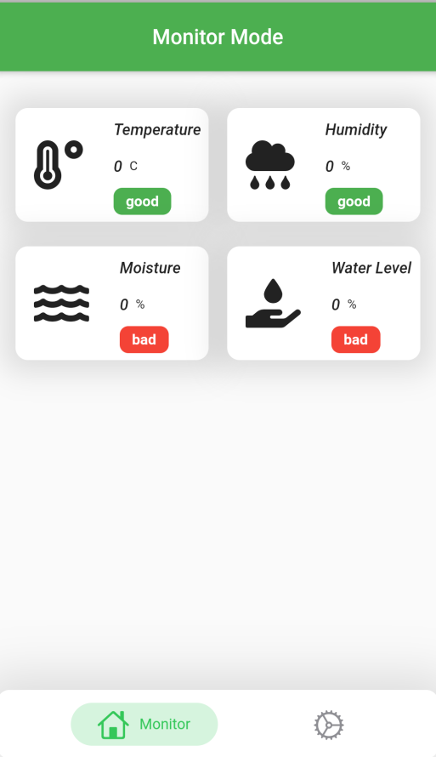

Figure 3-16: Monitor Screen

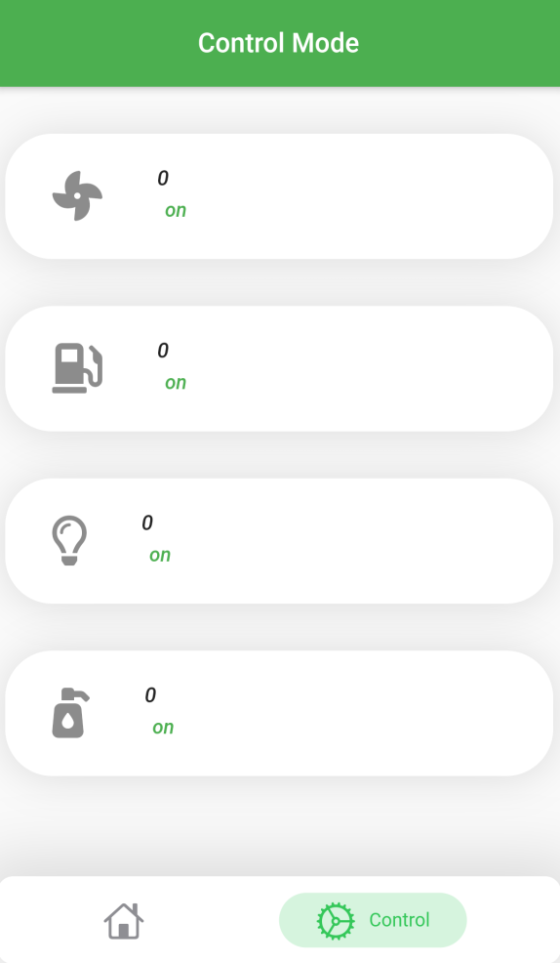

Figure 3-17: Control Screen

## Software Requirements

For software application, we require

-Proteus for hardware simulation.

-Arduino IDE for program arduino:

Arduino IDE is a software application that enables C programme to compile and upload it to the Arduino board. It is programmed to work with different types of microcontroller. Once after compiling and uploading the code necessary action is performed.

-VSCode to develop the android app.

System should be compatible to:

CPU: 2.0 GHz processor and above.

RAM:4Gb or above.

OS: Windows 7 or above

## System Architecture

#Yassir Please don’t forget to put the sketch here ☺

## Hardware implementation

Here we distributed the sensors in the field and connected them with the Arduino and the Wi-Fi module using the Breadboard.

The sensors collect the data from the field and sends it to the Arduino, and it process them and make the required actions like: opening fans, lights, irrigation system based on this data and the cultivated crop, and also sends the data to the cloud server.

Also the system has an ability to receive commands from the mobile application and executes them.

All of the above is done through writing an Arduino c program using the Arduino IDE.

#Yassir please mention in details steps of connecting all these component together ☺

#We will change all these bad pictures later ☺

Arduino mega

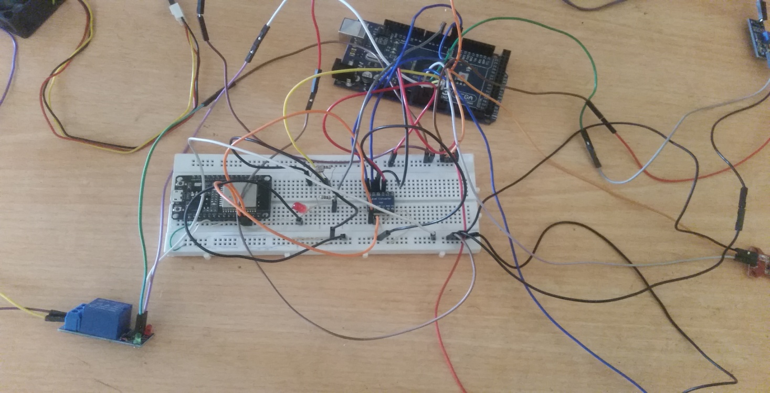

Fig.17 system overview

DHT11 bread board jumper wires

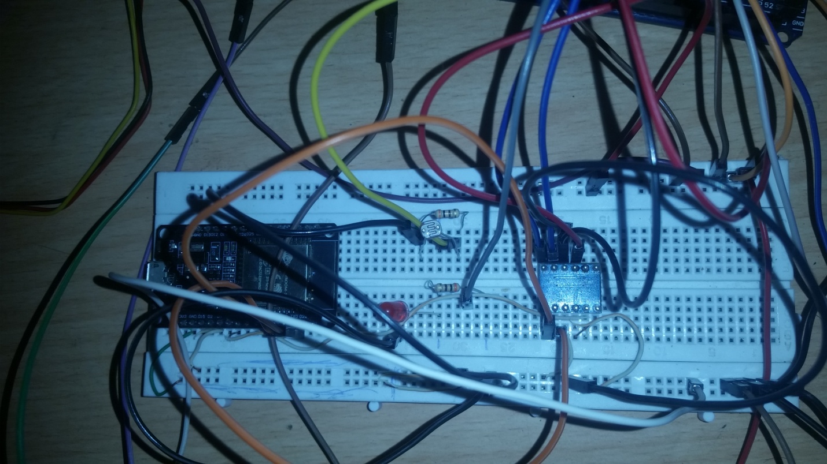

Fig.18 system overview

ESP32 voltage divider

Soil moisure sensor Water level sensor

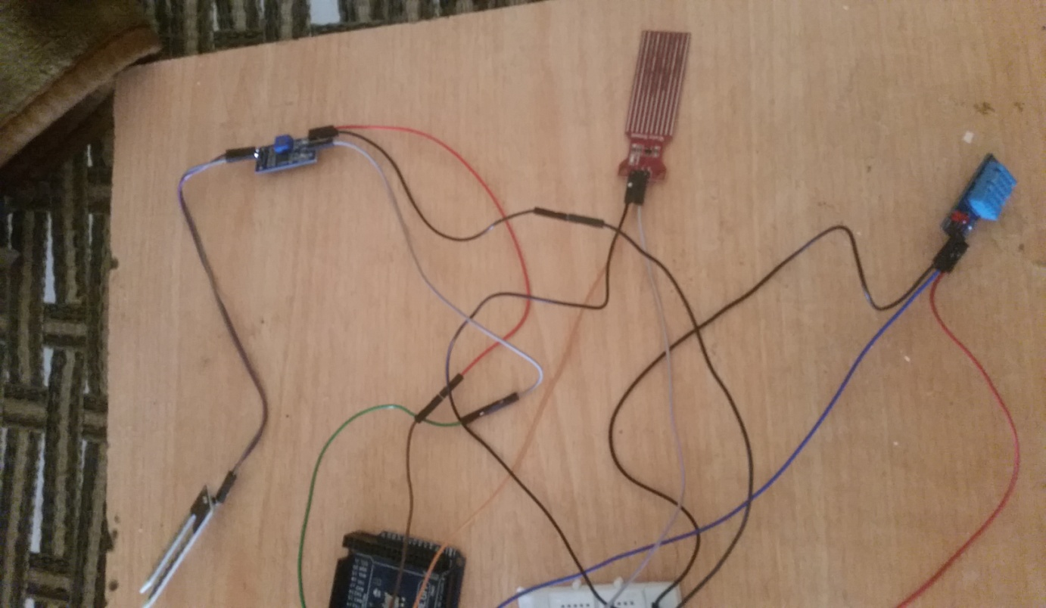

Fig.19 system overview

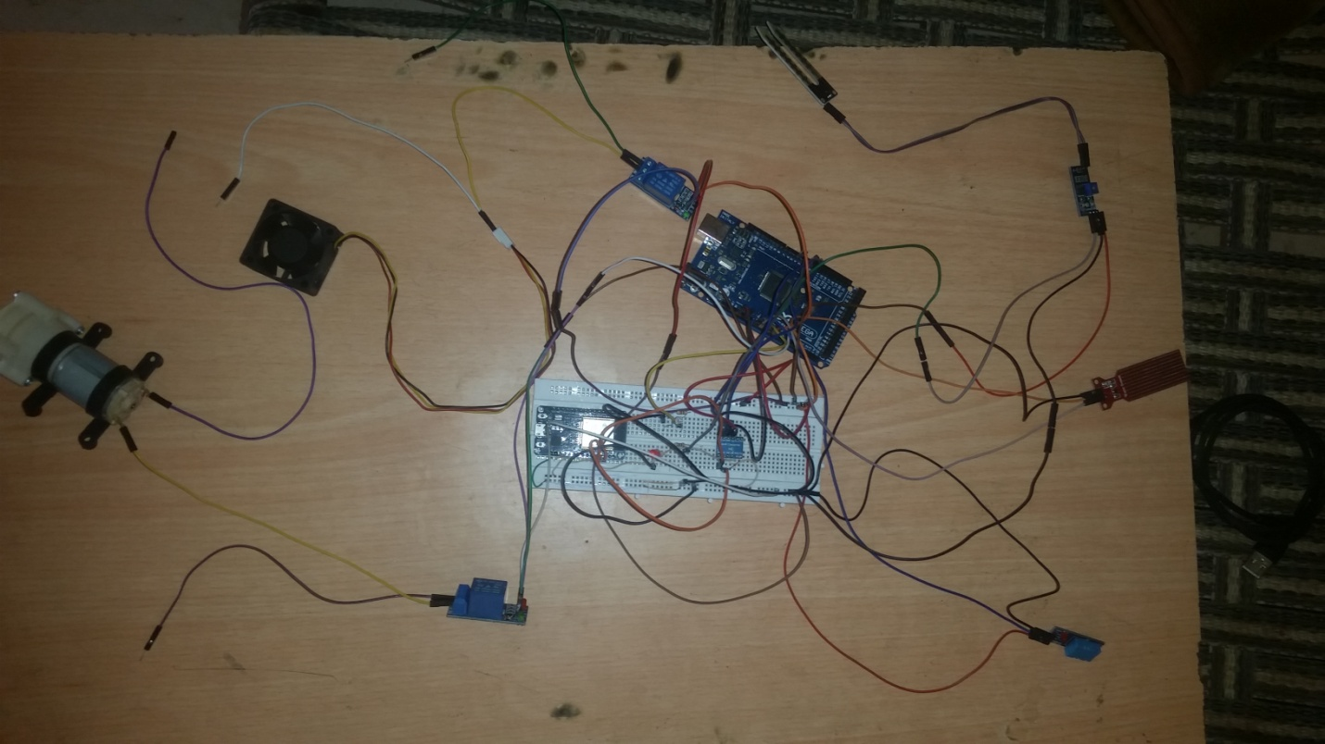

Fig.20 system overview

Water pump Fan Relay

## References:

[1] S. Nandurkar, V. Thool, and R. Thool, "Design and development of precision agriculture system using wireless sensor network," *2014 First International Conference on Automation, Control, Energy and Systems (ACES),* pp. 1-6, 2014.

[2] Q. Wang, A. Terzis, and A. Szalay, "A novel soil measuring wireless sensor network," in *2010 IEEE Instrumentation & Measurement Technology Conference Proceedings*, 2010: IEEE, pp. 412-415.

[3] N. Kotamäki *et al.*, "Wireless in-situ sensor network for agriculture and water monitoring on a river basin scale in southern Finland: Evaluation from a data user’s perspective," *Sensors,* vol. 9, no. 4, pp. 2862-2883, 2009.

[4] P. Vijayabaskar, R. Sreemathi, and E. Keertanaa, "Crop prediction using predictive analytics," in *2017 International Conference on Computation of Power, Energy Information and Commuincation (ICCPEIC)*, 2017: IEEE, pp. 370-373.

[5] S. Jegadeesan and G. Venkatesan, "Smart cow health monitoring, farm environmental monitoring and control system using wireless sensor networks," *Int. J. Adv. Eng. Tech,* vol. 7, 2016.

[6] O. Mirabella and M. Brischetto, "A hybrid wired/wireless networking infrastructure for greenhouse management," *IEEE transactions on instrumentation and measurement,* vol. 60, no. 2, pp. 398-407, 2010.

*[7]* <https://thingsboard.io/docs/getting-started-guides/what-is-thingsboard/>

*[8]* [*https://www.techoped1ia.com/definition/29807/remote-procedural-call-server-rpc-server/*](https://www.techoped1ia.com/definition/29807/remote-procedural-call-server-rpc-server/)

*[9]* [*https://mqtt.org/*](https://mqtt.org/)

*[10]* [*https://en.wikipedia.org/wiki/Constrained_Application_Protocol/*](https://en.wikipedia.org/wiki/Constrained_Application_Protocol/)

*[11] https://en.wikipedia.org/wiki/Flutter_(software)/*